Chemistry Syllabus

Teacher: Kaleb Reese Phone: 503-431-5459
e-mail: kreese@ttsd.k12.or.us

Class web site: http://reeseka.weebly.com

Course Overview
Welcome to Tigard High’s introductory chemistry course designed to give students a foundational understanding of matter and its interactions, meeting both pre-IB chemistry expectations and the Oregon Department of Education chemistry-related science benchmarks. Apart from being a branch of science worthy of study in its own right, chemistry is a prerequisite for many other areas of science, such as medicine, ecology, forensics, and oceanography. Although it can sometimes become quite challenging, most students who stay on top of their work and come in for help when needed do well in here, enjoy the course, and take pride in their new understanding of the world around them. To this end, I have an open-door policy and will nearly always be available for help, or you can just come in whenever you want just to have a quiet place to study and where answer keys for most assignments will be available.

Course Materials
- Calculator: You will need a Scientific calculator to do work outside of class, one that has an EXP, EE, or Sci button for scientific notation. You will need to bring it with you everyday of class!
- Notebook: Students are required to use a class composition notebook for all notes and assignments. These are available in class for $1.
- Headphones: Every student will need a set of headphones to use with our classroom laptops.

Class Notes
Students who are successful in this class are usually those who maintain good classroom notes. As nearly all tests and quizzes are written directly from material covered in class, it will be well worth your time to keep your notebook filled with all lecture, reading, and lab notes, as well as all problems we go over on the board.

Homework
There will almost always be something you should be working on or reviewing, such as readings from your textbook and associated practice problems, revising classroom notes, completing a lab worksheet, or reviewing an online tutorial. Mastering such assignments will be essential if you hope to demonstrate your understanding on tests and quizzes.

Assignment Due Dates

☞ Unless told otherwise, always assume any assignment started in class will be due the following day.

☞ Homework assignments will be given in class and placed on our class web site. Students are expected to keep track of these assignments and know when they are due.

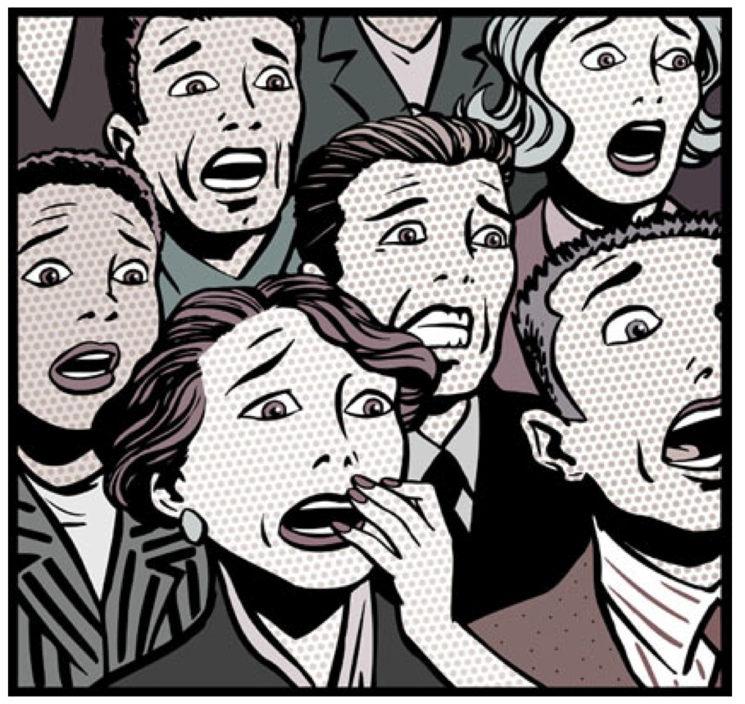☞ Late work will be accepted, but you’re not going to like your score if you do!
- All work must be turned in on the date due, at the start of class...
- Only 75% credit after the first day.
- No credit after 1 week.
Quality of Work
The work you turn in must meet the following basic requirements or it will be returned ungraded:
- Contains a proper heading, including your name, date, and assignment specifics (e.g., Page 45, problems 1-8).
- Is neat, legible, and well-spaced (providing ample room for corrections and comments).
- Write in any color you want, as long as I can see it.
 Special Note On "Showing All Work”:
One of the most important skills students need is the ability to demonstrate all of the steps necessary to solve a particular problem. I will go to great lengths to show exactly what is expected, so simply follow my instructions and in-class examples and all will be fine.

However, no matter how much this is emphasized there are always students who want to argue that they should not have to show work if they understand “it” and are able to arrive at the correct answer. Unfortunately, this is not what science is all about. Correct answers are near meaningless without the ability to communicate the process by which they were arrived. This ability to communicate, often mathematically, is a primary skill of any scientist. So please be forewarned of this now, for I will not argue the point further: No work = no credit.

Lab Work
There will be an average of one or two labs every week. Most labs will simply be a matter of completing an accompanying worksheet, others requiring far more time and work both in and out of class.

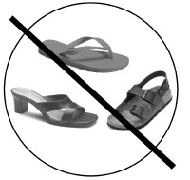Note: You are expected to wear proper shoes on lab days, ones that will protect your feet should you have an accident. Open-toed shoes, flip-flops, high-heels, slippers, etc, are not acceptable. If you think this might be a problem for you, please plan to keep a back-up pair of shoes in your locker. If you wear improper shoes on a lab day you will be marked tardy, as you are arriving to class unprepared. However, you will be given a pair of disposable shoe covers so that you may proceed with that day’s investigation.

Tests and Quizzes
Quizzes
There will be one or more short quizzes nearly every week covering recent material and essential skills, with most being open-note quizzes.

Tests
Tests will be given at the end of every unit and will often take the entire 90 minute period to complete. You will be allowed to use one 5x8 note card on tests. At the end of the course you will be given a comprehensive final exam covering all material from both quarters.

Make-up Work (excused absences only)
As per THS policy, you will have the same number of days absent plus two to make-up any missed assignment. However, it will be your responsibility to find out what you have missed and what is required to get caught-up.

Missed Labs / Open Lab
Every day I will be around in my office between rooms 313 and 317 during 2nd period. This is an “Open Lab” time for students to make-up any missed lab from the previous week. You do not need to make an appointment, just show up and be ready to work. Because there are plenty of opportunities for you to make-up, no labs will be accepted after 1 week, so get in and get them done.

Missed Tests or Quizzes
If you are absent on the day of a test or quiz you will have 5 school days to make it up upon your return. For prearranged absences, the test or quiz should be taken before the day of your absence, pop quizzes upon your return.

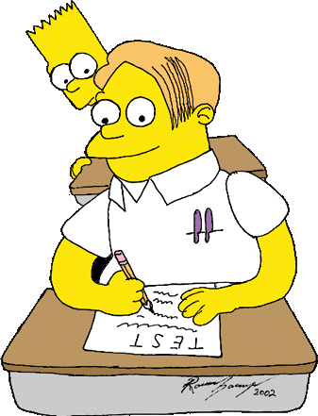

Grading

Consequences for Cheating
Students who copy work from another student will receive a zero on the assignment, a call home, and possibly an administrative referral. Additionally, students who allow their work to be copied will also receive a zero.

Grades are weighted: 70% Tests and Quizzes
30% All other coursework Quarter Grade Determination:
A = 90% | C = 70% - 79% | F = 59%
B = 80% - 89% | D = 60% - 69%

Attendance Policies

Absences ☹☹
All absences must be reported by a parent or guardian calling our school attendance line at 503-431-5430 within 24 hours of an absent. According to THS policy, if a student returns without this being done, he or she will receive detention. (Please note that Tigard High does not accept written notes to excuse an absence or tardy.)

Tardies ☹☹
Students who are not ready to start work at the start of class will be marked tardy. This includes not being in your seat, wearing improper shoes on a lab day, or anything else that requires class time to correct.

Tardy Policy:
  - 1st & 2nd tardy: Verbal warning and an angry scowl
  - 3rd & 4th tardy: 30 minutes classroom cleanup ☺☺
  - 5th tardy: Administrative Referral 

Please Beware! According to THS policy, parents cannot excuse a tardy. If getting to school on time is problematic in your home, start planning now on how to overcome your situation, for regardless of who is at fault, if you are late to class it will be a recorded tardy. (FYI: The only accepted excuse for a tardy is a note from a teacher or doctor.)

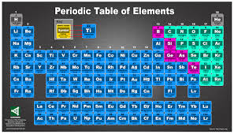

Zero Tolerance for Electronic Devices

Cell phones, music players, etc. must be turned off and put away before you enter the room. All such devices will be confiscated. Some days I will allow you to use them in class, otherwise if I see them out they become mine for the class.

Classroom Policies and Expectations
1.) Everyone is to be treated with courtesy and respect. 2.) No food or drinks are allowed, except bottled water. 3.) All work done must be for this class only.
4.) Work areas must always be left clean and neat, with stools placed back under the counters. 5.) All lab safety rules must be followed in complete accordance with the lab safety policies.
6.) Bathroom passes will require students to leave their cell phones within the classroom.

Please know that I will almost always be available for help during second lunch and 2nd periods in my office. However, I prefer if you make an appointment with me ahead of time (just see me to set up a time). Also, please feel free to call me or send an e-mail whenever you need help, have a question, or just need to talk something over. If I’m not available, just leave a message on my voicemail and I’ll get back to you as soon as possible.

AND... please remember to visit our class web site! Daily lessons, assignments, and general course information can be found there, as well as many helpful Chemistry links. It will be updated continually throughout the semester and is an excellent resource for students and parents.

