Physical Science Syllabus

Teacher: Kaleb Reese Phone: 503-431-5459
e-mail: kreese@ttsd.k12.or.us

Class web site: http://reeseka.weebly.com

Course Overview
This laboratory science course consists of one quarter of introductory level Chemistry and one quarter on introductory Physics which is structured to teach and utilize the scientific method and metric measurements in all units. Emphasis is placed on inquiry-style learning and development of skills such as observing, inferring, data collecting, and graphing.

Course Materials
- Calculator: You will need a Scientific calculator to do work outside of class, one that has an EXP, EE, or Sci button for scientific notation. You will need to bring it with you everyday of class!
- Pencil: You will be writing something in class every day.

Class Notes
Students who are successful in this class are usually those who maintain good classroom notes. As nearly all tests and quizzes are written directly from material covered in class, it will be well worth your time to keep your notebook filled with all lecture, reading, and lab notes, as well as all problems we go over on the board.

Homework
There will be one assignment given every Monday, and it will be due the next Monday. However, there will almost always be something you should be working on or reviewing, such as readings from your textbook and associated practice problems, revising classroom notes, completing a lab worksheet, or reviewing an online tutorial. Mastering such assignments will be essential if you hope to demonstrate your understanding on tests and quizzes.

Assignment Due Dates

☞ Unless told otherwise, always assume any assignment started in class will be due that day.

☞ Homework assignments will be given in class every Monday. Students are expected to keep track of these assignments and know when they are due.

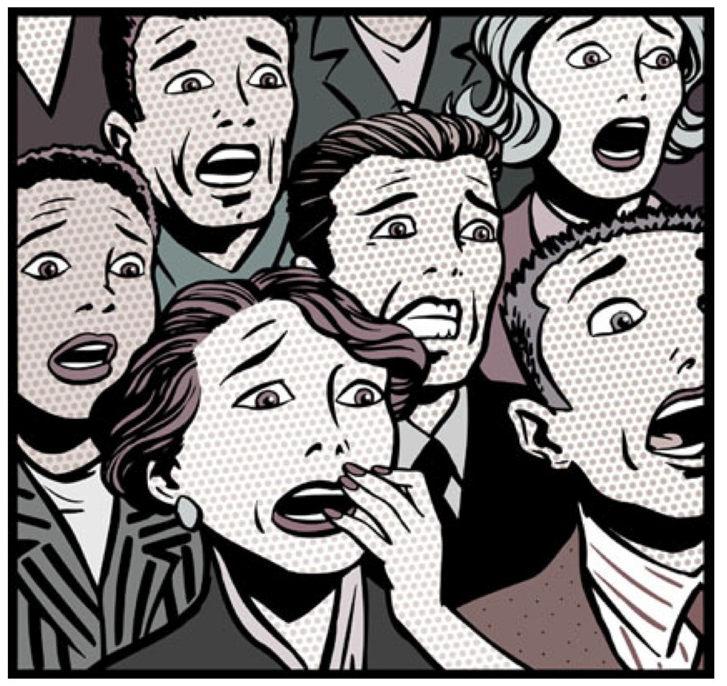☞ Late work will be accepted, but you’re not going to like your score if you do!
- All work must be turned in on the date due, at the start of class...
- Only 75% credit after the first day.
- 75% is still better than nothing, get it done and turned in!

Showing Work

One of the most important skills students need will need to demonstrate will be showing all the steps necessary to solve a particular problem. I will go to great lengths to show exactly what is expected, so simply follow my instructions and in-class examples and all will be fine.

However, no matter how much this is emphasized there are always students who want to argue that they should not have to show work if they understand “it” and are able to arrive at the correct answer. Unfortunately, this is not what science is all about. Correct answers are near meaningless without the ability to communicate the process by which they were arrived. This ability to communicate, often mathematically, is a primary skill of any scientist. So please be forewarned of this now, for I will not argue the point further: No work = no credit.

Lab Work
There will be an average of one or two labs every week. Most labs will simply be a matter of completing an accompanying worksheet, others requiring far more time and work both in and out of class.

Tests, Quizzes, and Projects
Quizzes
There will be one or more short quizzes nearly every week covering recent material and essential skills, with most being open-note quizzes.

Tests
Tests will be given at the end of every unit, sometimes you will be allowed notes, sometimes not.

Projects
There will be either lab based projects, or group activity projects during some units. These will require your attendance to complete.

Make-up Work (excused absences only)
As per THS policy, you will have the same number of days absent plus two to make-up any missed assignment. However, it will be your responsibility to find out what you have missed and what is required to get caught-up.

Missed Labs / Open Lab
Every day I will be around in between rooms 313 and 317 during 2nd period. This is an “Open Lab” time for students to make-up any missed lab from the previous week. You do not need to make an appointment, just show up and be ready to work. Because there are plenty of opportunities for you to make-up.

Missed Tests or Quizzes
If you are absent on the day of a test or quiz you need to take it upon yourself to come in and get it done. Remember a low amount of points is still better than 0 points. For prearranged absences, the test or quiz should be taken before the day of your absence.

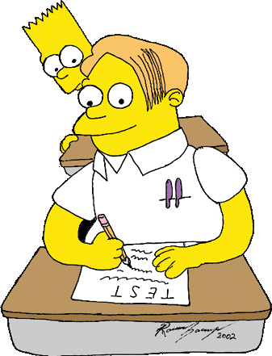

Grading

Consequences for Cheating
Students who copy work from another student will receive a zero on the assignment, a call home, and possibly an administrative referral. Additionally, students who allow their work to be copied will also receive a zero.

Grades are weighted: 60% Tests, Quizzes, and Lab based Tests
40% All other coursework Quarter Grade Determination:
A = 90% | C = 70% - 79% | F = 59%
B = 80% - 89% | D = 60% - 69%

Attendance Policies

Absences ☹☹
All absences must be reported by a parent or guardian calling our school attendance line at 503-431-5430 within 24 hours of an absent. According to THS policy, if a student returns without this being done, he or she will receive detention. (Please note that Tigard High does not accept written notes to excuse an absence or tardy.)

Tardies ☹☹
Students who are not ready to start work at the start of class will be marked tardy. This includes not being in your seat, wearing improper shoes on a lab day, or anything else that requires class time to correct.

Tardy Policy:
  - 1st & 2nd tardy: Verbal warning and an angry scowl
  - 3rd & 4th tardy: 30 minutes classroom cleanup ☺☺
  - 5th tardy: Administrative Referral 

Please Beware! According to THS policy, parents cannot excuse a tardy. If getting to school on time is problematic in your home, start planning now on how to overcome your situation, for regardless of who is at fault, if you are late to class it will be a recorded tardy. (FYI: The only accepted excuse for a tardy is a note from a teacher or doctor.)

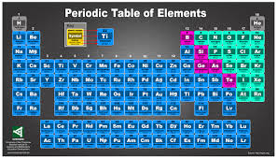

Zero Tolerance for Electronic Devices

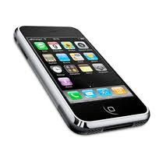Cell phones, music players, etc. must be turned off and put away before you enter the room. All such devices will be confiscated. Some days you get to use them!

Classroom Policies and Expectations
1.) Everyone is to be treated with courtesy and respect. 2.) No food or drinks are allowed, except bottled water
3.) All work done must be for this class only.
4.) Work areas must always be left clean and neat, with stools placed back under the counters. 5.) All lab safety rules must be followed in complete accordance with the lab safety policies.
6.) Bathroom passes will require students to leave their cell phones within the classroom.

Please know that I will almost always be available for help during second lunch and 2nd periods in my office. However, I prefer if you make an appointment with me ahead of time (just see me to set up a time). Also, please feel free to call me or send an e-mail whenever you need help, have a question, or just need to talk something over. If I’m not available, just leave a message on my voicemail and I’ll get back to you as soon as possible.

